Feb, 23rd-Friday
Time | activity | cost per person
9.00-10.00 | Travel to Szczecin  Sharing and exchanging project products:  *photos, ppt presentations, documents, after exchange surveys results, etc.
10.30-11.00 | A meeting at Cafe,  Coffee & refreshment - “Kaskada” Shopping Center
12.00-1.00 p.m. | A visit to The National Museum  http://muzeum.szczecin.pl/en/about/seats/the-national-museum-in-szczecin-the-museum-of-regional-traditions.html | 5 pln
2.00-4.00 p.m. | Lunch in a restaurant  At “ Sowa Restaurant”  https://sowa-restauracja-szczecin.pl/szczecin/  A la carte | 80pln
4.00-6.00 p.m. | Free time for visiting  Café 22 / “Galaxy” Shopping Center  https://cafe22.pl/en/
6.00-7.30 p.m. | Travel back to Barlinek
8.30 p.m. | Farewell dinned  Land Restaurant  Fixed menu | 80pln
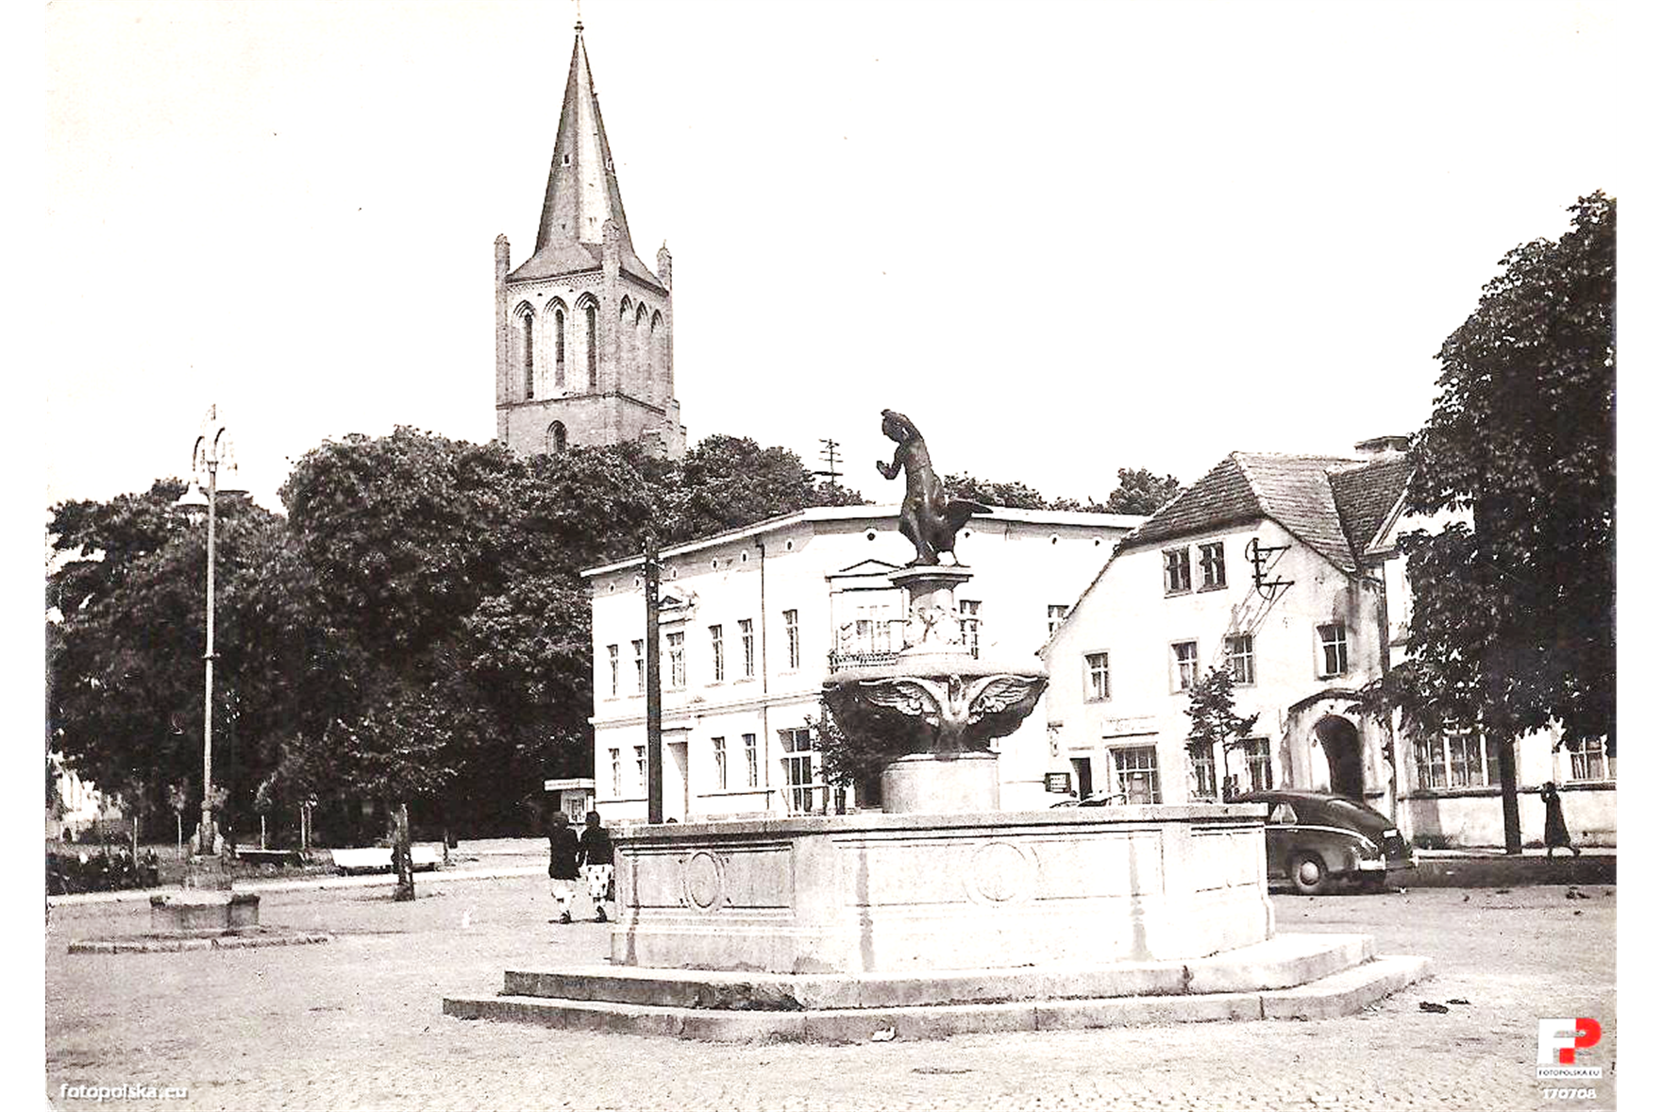
Feb, 24th Saturday
Departures 10.00 a.m. (bus to Berlin)

